



*NCJET*

“Compete With The Elite”

YOUTH SCRATCH SPORT TOURNAMENT

# JR GOLD EVENT

**April 14, 2019**

AT

Sea Bowl, 4625 Coast Highway

Pacifica, CA – 1-(650)738-8190

# $2 Brackets

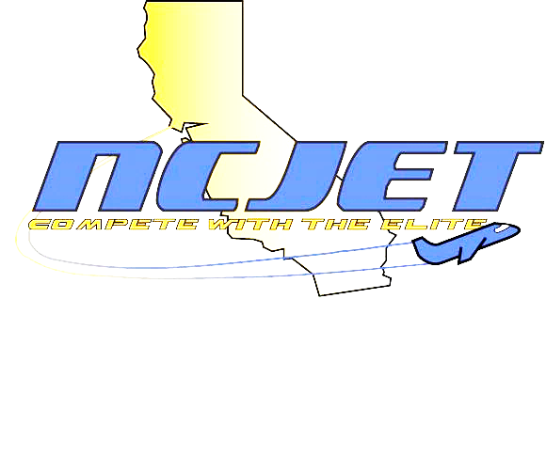

4 games of Qualifying on

Sport Pattern

Boys 190/up, 189/under

Girls 180/up, 179/under

Pinfall carries over

to match play

Top 3 Advance to Stepladder Finals

Check in at 9:00 a.m. – Start at 10:00 a.m.

ENTRY FEES $28.00 lineage est.*

$ 5.00 NCJET membership**

 $17.00 prize fund

$50.00 Entry Fee

Sign up now at Tournamentbowl.com

USBC Certified Tournament

Email for more information – NorCalJrEliteTour@gmail.com



* Actual lineage varies depending on rate of host center

** NCJET membership fee is only required once per tournament year (September – August)